Understanding the Movement Variability of Simplistic Gestures Using an Inertial Sensor

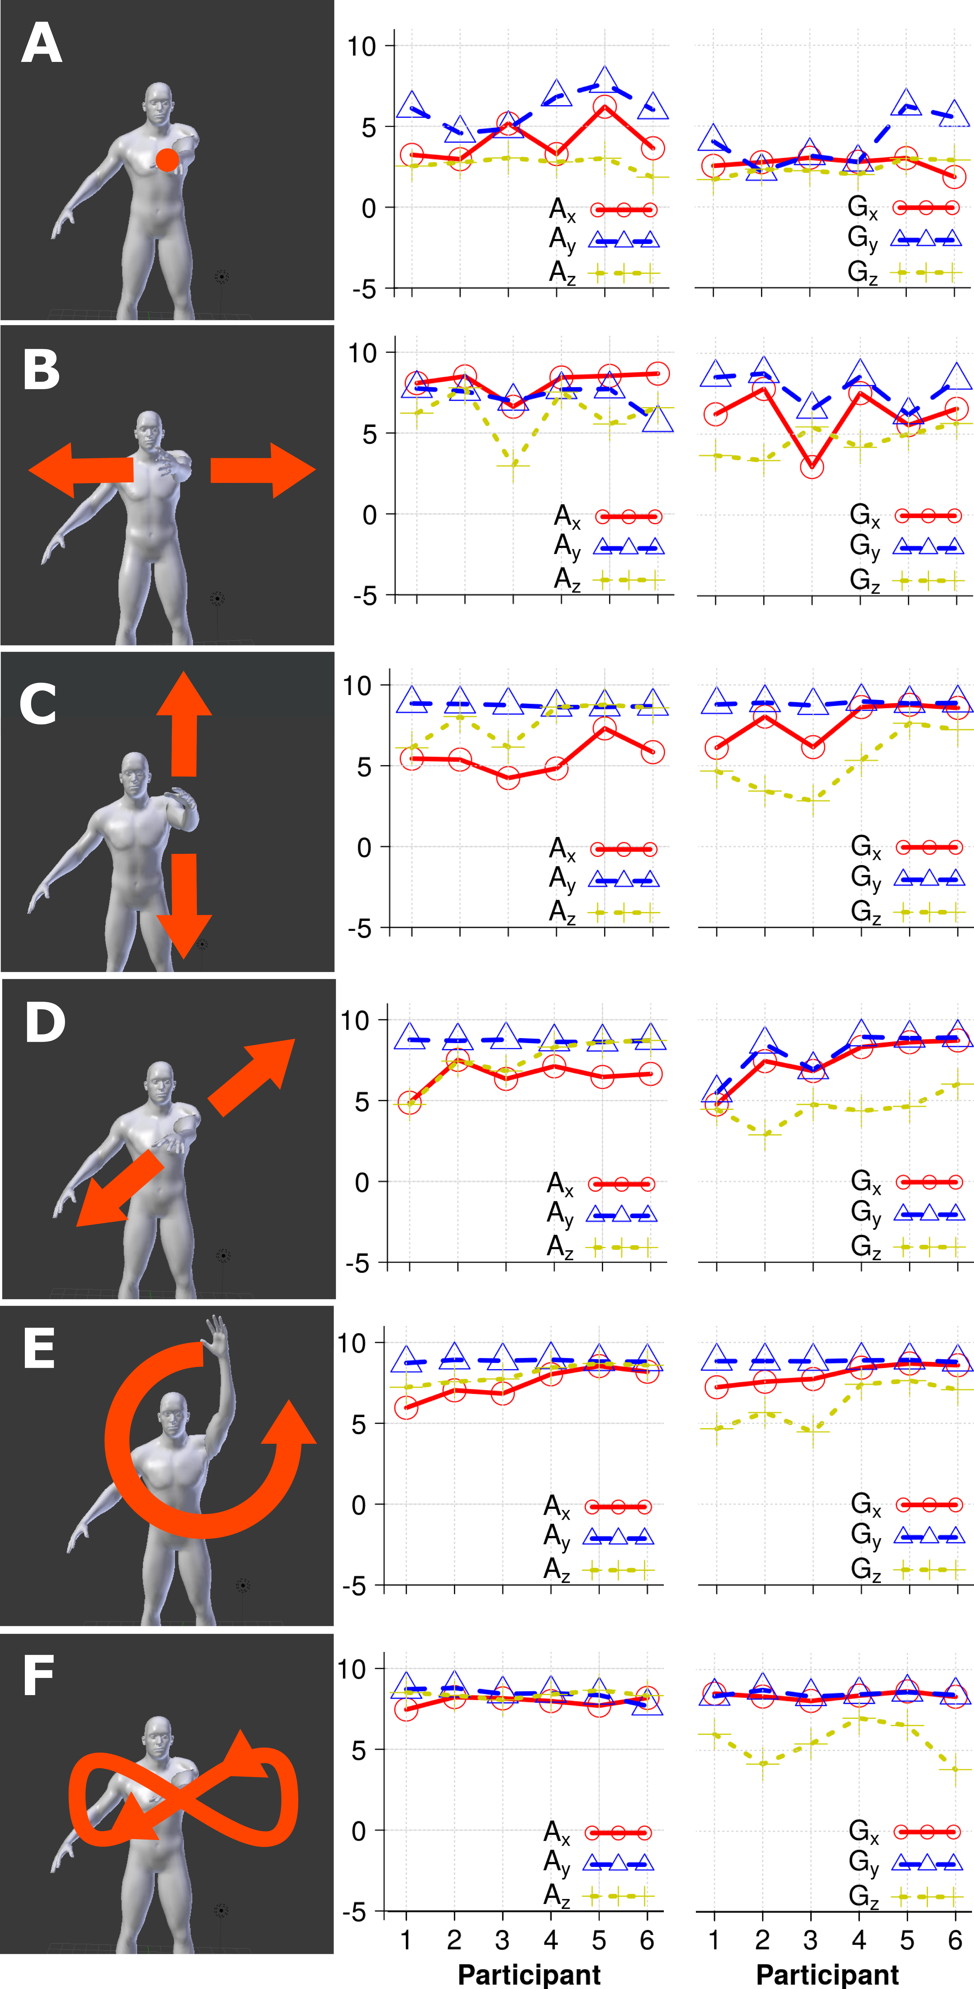

Figure 1 First column of figures show six simplistic gestures ((A) static, (B) horizontal, (C) vertical, (D) diagonal, (E) circular and (F) eight shape). Second column and third column present the cumulative energy for both six movements and six participants. The percentage of cumulative energy is computed for each axis of the triaxial accelerometer and triaxial gyroscope.

*Please do not modify this text block until you receive explicit instructions.*

Permission to make digital or hard copies of all or part of this work for personal or classroom use is granted without fee provided that copies are not made or distributed for profit or commercial advantage and that copies bear this notice and the full citation on the first page. Copyrights for components of this work owned by others than the author(s) must be honored. Abstracting with credit is permitted. To copy otherwise, or republish, to post on servers or to redistribute to lists, requires prior specific permission and/or a fee. Request permissions from [Permissions@acm.org](mailto:Permissions@acm.org).

*CONF '22,* Jan 1 - Dec 31 2022, Authorberg.

Copyright is held by the owner/author(s). Publication rights licensed to ACM. ACM 978-1-xxxx-yyyy-z/zz/zz…$zz.00.

unique doi string will go here

# Abstract

First Author

University of Author

Authortown, CA 94022, USA

author1@anotherco.edu

Second Author

VP, Authoring

Authorship Holdings, Ltd.

Awdur SA22 8PP, UK author2@author.ac.uk

Third Author

Fourth Author

Lēkhaka Interaction Labs

Bengaluru 560 080, India

We present a preliminary experiment to understand the movement variability of 6 simplistic movements. For the experiment we asked six participants to wear an inertial sensor to collect raw data as time series and we performed the time delay embedding theorem, PCA and its cumulative energy to present statistical evidence of the variability among users and activities. We aim to attract the community attention towards the use of wearable sensors for less constrained interactions with displays.

# Author Keywords

Time delay embedding; activity recognition; dimensionality reduction; phase space reconstruction

# ACM Classification Keywords

I.5 Pattern Recognition: general; G.3 Probability and statics: statistical computing, time series analysis

# Introduction

Movement variability (MV) is an inherent characteristic that occurs in human movement [1]. MV is, however, a common problem in activity recognition, for instance, users usually perform the same action slightly differently trial by trial. For these reason we are interested in the analysis of the variability of simplistic movement that can give insight in understanding the variably among activities and among persons. MV is presented when users interact with displays. For instance, Zaiţi et al. explore kinematic variations of leap gestures such as gesture volume, gesture length, finger-to-palm distance and articulation speed [2].We, however, believe that users are constrained to be in specific postures in front of the sensors (e.g. Kinect and leap motion). We therefore consider that the freedom that wearable sensors (inertial sensors) offer is ideal for both comfortable and freely interaction with displays.

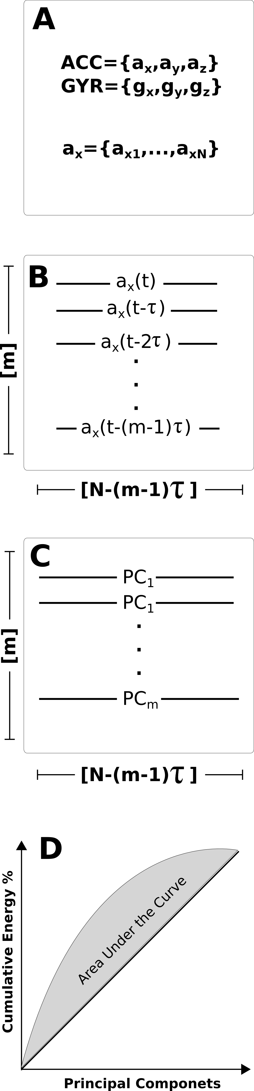

Figure 2 Framework representation for statistical representation of the variably: (A) raw data from inertial sensors, (B) Time-delay embedding, (C) PCA and (D) percentage of cumulative energy.

Figure 2 In this image, the cats are tesselated to save space. You, too, can save space by placing images in the sidebar. Images should have captions and be within the boundaries of the text box on Page 2. Photo CC-BY jofish on Flickr.

# Framework for the experiment

For the current work, we use the time-delay embedding and PCA techniques which can help us to provide insights into the variability of human movements. To this, the raw data is collected from triaxial accelerometer and triaxial gyroscope sensors. Then, the time-series, for instance, ***ax***, with a length of ***N*** samples is used to obtain the time-delay embedded matrix, ***E****{* ***ax*** *}*, [3] with *m* rows and *N − (m − 1)τ* columns. PCA algorithm is applied to obtain, via eigenvalues (*λ1,…,λm*) of eigenvectors (*v1,…,vm*), the principal components (*PC1,…,PCm*) of the time-delay embedded phase space. Finally, the percentage of cumulative energy is computed [4] (Fig. 2).

# Conclusion and Future work

Although the Time-delay embedding technique is subject to different values of embedded parameters (*m* and *τ*) according the length and complexity of the time-series, the technique is useful to statistically present the inherent features of variability between 6 participants for six different gestures (Fig. 1). In terms of the pervasive display community, we believe that MV that users show in interactive application is an ongoing trend towards extending the understanding of human movement towards the interactions that offer to users an alternative on the interaction and less constrains duo to the sensors regarding specific posture for interaction.

# Acknowledgements

X gratefully acknowledges the studentship from X for pursuing his postgraduate studies at X.

# Bibliography

|  |  |
| --- | --- |
| [1] | K. M. N. a. D. M. Corcos, Variability and motor control, United States of America: Human Kinetics Publishers, 1993. |
| [2] | I.-A. Zaiţi, P. Ştefan-Gheorghe and R.-D. Vatavu, "On free-hand TV control: experimental results on user-elicited gestures with Leap Motion," *Personal and Ubiquitous Computing,* vol. 19, pp. 821--838, 2015. |
| [3] | J. Frank, S. Mannor and D. Precup, "Activity and Gait Recognition with Time-Delay Embeddings," in *Proceedings of the Twenty-Fourth AAAI Conference on Artificial Intelligence*, 2010. |
| [4] | N. Y. Hammerla, T. Plötz, P. Andras and P. Olivier, "Assessing motor performance with pca," in *Proceedings of the International Workshop on Frontiers in Activity Recognition using Pervasive Sensing*, 2011. |